SIMATS ENGINEERING (SAVEETHA SCHOOL OF ENGINEERING)
Department of Artificial Intelligence and Data Science
ASSESSMENT TOOL 2 – Industry Problem Solving Task

Course Code: | DSA03 | Course Title: | Natural Language Processing
CO Assessed: | CO4 – Precision | Assessment: | Assessment Tool 2 – Industry Problem Solving Task
Weightage: | 35% of CIA
CO5 Statement: | Formulate context-free grammars, feature structures, probabilistic parsing techniques and to construct parsing frameworks. (BL-4)
Student Name: | G. Devi Sri | Reg. No.: | 192472025
Section / Batch: | CSE-AI | Date: | 17/08/2026

Code of Conduct
I G. Devi Sri / 192472025 (Name / Reg No) certify that this submission is my original work and that I have adhered to the guidelines specified for this assessment. I understand that any violation of academic integrity rules will result in disciplinary action.
Signature of the Student: G. Devi Sri

Instructions
- Read each industry scenario carefully before answering.
- Analyze the given problem from a semantic analysis perspective.
- Provide structured and logical answers with proper justification.
- Support your analysis using examples from the given scenario wherever applicable.
- Use suitable diagrams, semantic representations, logical predicates, workflows, architectures, or tables whenever necessary.
- Clearly state assumptions if additional information is required.
- Duration: 30 minutes.

Section / Topic | Focus | Question No.
Representing Meaning & Meaning Structure of Language | Analyze semantic interpretation of user queries, identify ambiguity in meaning representation, evaluate semantic processing limitations, and improve understanding in banking chatbot applications. | Q1
Syntax-Driven Semantic Analysis | Analyze multiple interpretations of spoken commands, evaluate parsing-related ambiguity, and assess semantic extraction in real-time voice assistant systems. | Q2
First-Order Predicate Calculus, Representing Linguistically Relevant Concepts, Syntax-Driven Semantic Analysis | Design a semantic processing architecture for healthcare reports, model relationships among entities and actions, represent linguistic concepts, and improve semantic extraction accuracy. | Q3

Annexure A – Industry Problem Solving Task
1. AI-Powered Insurance Claim Processing System
An insurance company is developing an NLP-based system to automatically process customer insurance claims. The system uses Context-Free Grammar (CFG) to parse customer statements and extract information such as the claimant, damaged object, cause of damage, and claim amount.
However, the system faces the following problems:
- Ambiguous sentence structures
- Difficulty distinguishing noun and prepositional phrase attachment
- Subject–verb agreement errors
- Inefficient parsing of lengthy customer descriptions
- Difficulty handling conversational and incomplete input
Example customer statement:
"I reported the damage to the car after the accident."
The sentence can produce different interpretations depending on whether "to the car" is associated with reported or damage.
Tasks:
a) Analyze the structural ambiguity in the given sentence using CFG and illustrate the possible interpretations.
b) Evaluate the limitations of a basic CFG in handling ambiguity, agreement, and long customer-generated insurance statements.
c) Design an improved parsing approach using PCFG, Feature Structures, and Earley Parsing to resolve ambiguity and efficiently process the claim.
d) Justify how the proposed architecture can improve the accuracy, scalability, and reliability of automated insurance claim processing.

2. Intelligent Railway Ticket Booking Assistant
A railway company is developing a conversational AI assistant for ticket booking. The system currently uses top-down parsing to interpret passenger requests.
The system encounters:
- Excessive backtracking
- Ambiguous attachment of phrases
- Incomplete passenger requests
- Long-distance dependencies
- Slow response for complex queries
Example passenger request:
"Book two tickets from Chennai to Delhi for my parents with AC sleeper."
The system sometimes incorrectly associates "with AC sleeper" with the passengers instead of the ticket/class information.
Tasks:
a) Analyze the possible syntactic interpretations of the given passenger request using CFG.
b) Evaluate why top-down parsing may result in excessive backtracking and inefficient processing for conversational ticket-booking queries.
c) Analyze how Earley Parsing can handle ambiguity, incomplete input, and different possible parse structures more effectively.
d) Compare Top-Down Parsing, CFG-based parsing, and Earley Parsing in terms of ambiguity handling, computational efficiency, partial-input processing, and suitability for real-time railway booking systems.

3. AI-Based Legal Contract Analysis System
A legal technology company is developing an NLP system to analyze contracts and automatically identify:
- Parties involved
- Obligations
- Conditions
- Deadlines
- Actions
- Exceptions
The existing system uses a basic CFG parser. However, it produces incorrect interpretations when processing long legal sentences containing relative clauses, passive constructions, and multiple prepositional phrases.
Example contract sentence:
"The supplier who delivered the equipment to the company must replace the defective components within thirty days."
The system sometimes incorrectly identifies the company as the entity responsible for delivering the equipment.
Tasks:
a) Analyze the syntactic structure of the given sentence using CFG and identify possible sources of ambiguity.
b) Evaluate why basic CFG is insufficient for accurately interpreting complex legal sentences containing relative clauses and nested structures.
c) Design an NLP architecture integrating CFG, PCFG, Feature Structures, and Earley Parsing to improve syntactic and semantic interpretation.
d) Develop a step-by-step processing workflow showing how the system can extract:
- Supplier
- Action
- Equipment
- Company
- Obligation
- Deadline
and justify how the proposed approach improves automated contract analysis.

4. AI-Based E-Commerce Product Search System
An e-commerce company is developing a conversational product-search system. Customers enter natural-language queries rather than selecting predefined filters.
The current system uses CFG but faces difficulties with:
- Ambiguous phrase attachment
- Coordination
- Missing words
- Informal customer queries
- Long product descriptions
- Real-time search requirements
Example user query:
"Find laptops with a touchscreen for students under ₹60,000."
The system may incorrectly associate "for students" with the touchscreen rather than the laptop.
Tasks:
a) Analyze the syntactic ambiguity in the given query and construct possible parse interpretations using CFG.
b) Evaluate the limitations of CFG in handling informal, elliptical, and ambiguous e-commerce search queries.
c) Propose an improved parsing architecture using PCFG, Feature Structures, and Earley Parsing to identify product attributes, user requirements, and price constraints.
d) Justify how the proposed solution can improve search precision, response time, and customer experience in a large-scale e-commerce platform.

5. Intelligent Airline Voice Assistant
An airline is developing a real-time voice assistant that allows passengers to modify flight bookings using spoken commands.
The system currently uses a conventional top-down parser. It experiences:
- Backtracking
- Ambiguous attachment
- Speech recognition errors
- Incomplete commands
- Delayed responses
- Difficulty interpreting corrections made by users
Example spoken command:
"Change my flight to Mumbai tomorrow with two passengers."
Depending on the parse, "with two passengers" may be incorrectly interpreted as an attribute of the destination rather than the number of passengers.
The passenger may also say:
"Change my flight to Mumbai tomorrow... actually, make that Bangalore."
Tasks:
a) Analyze the possible syntactic structures and ambiguities in the given voice command.
b) Evaluate the limitations of top-down parsing when processing incomplete, corrected, and ambiguous spoken commands in real time.
c) Design a parsing architecture using Earley Parsing, PCFG, and Feature Structures to support partial input, ambiguity resolution, and agreement constraints.
d) Develop a processing workflow showing how speech input can be converted into a structured booking request and justify the proposed method for real-time airline applications.

1.
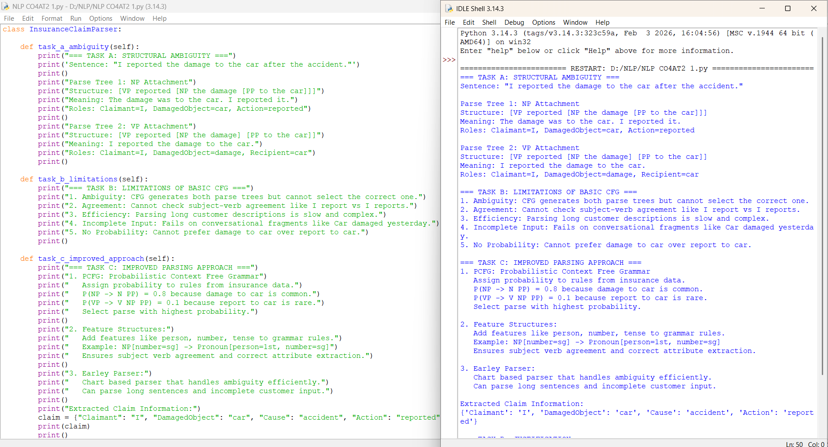

2.
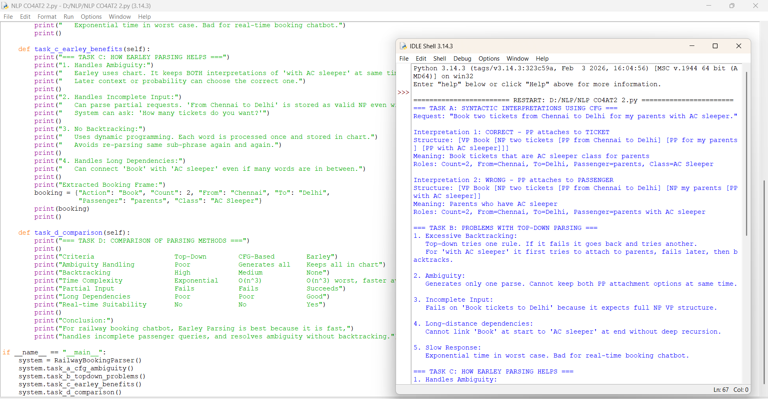

3.
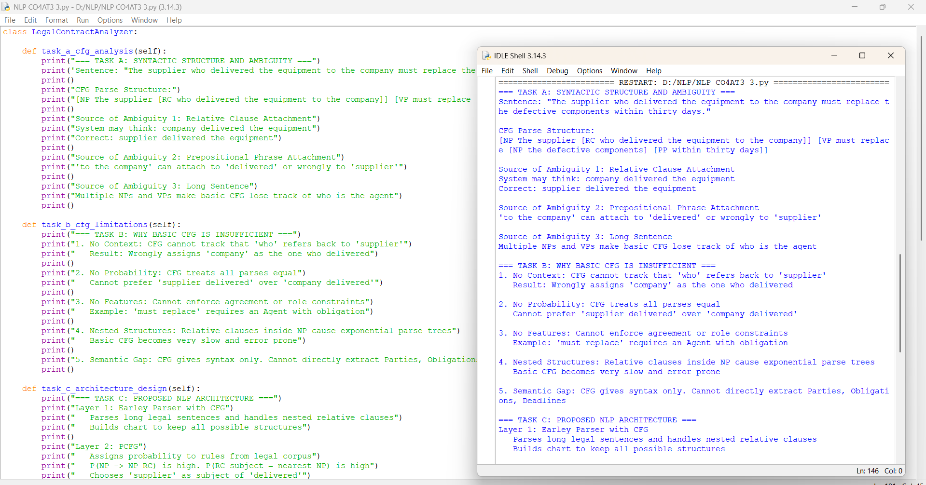

4.

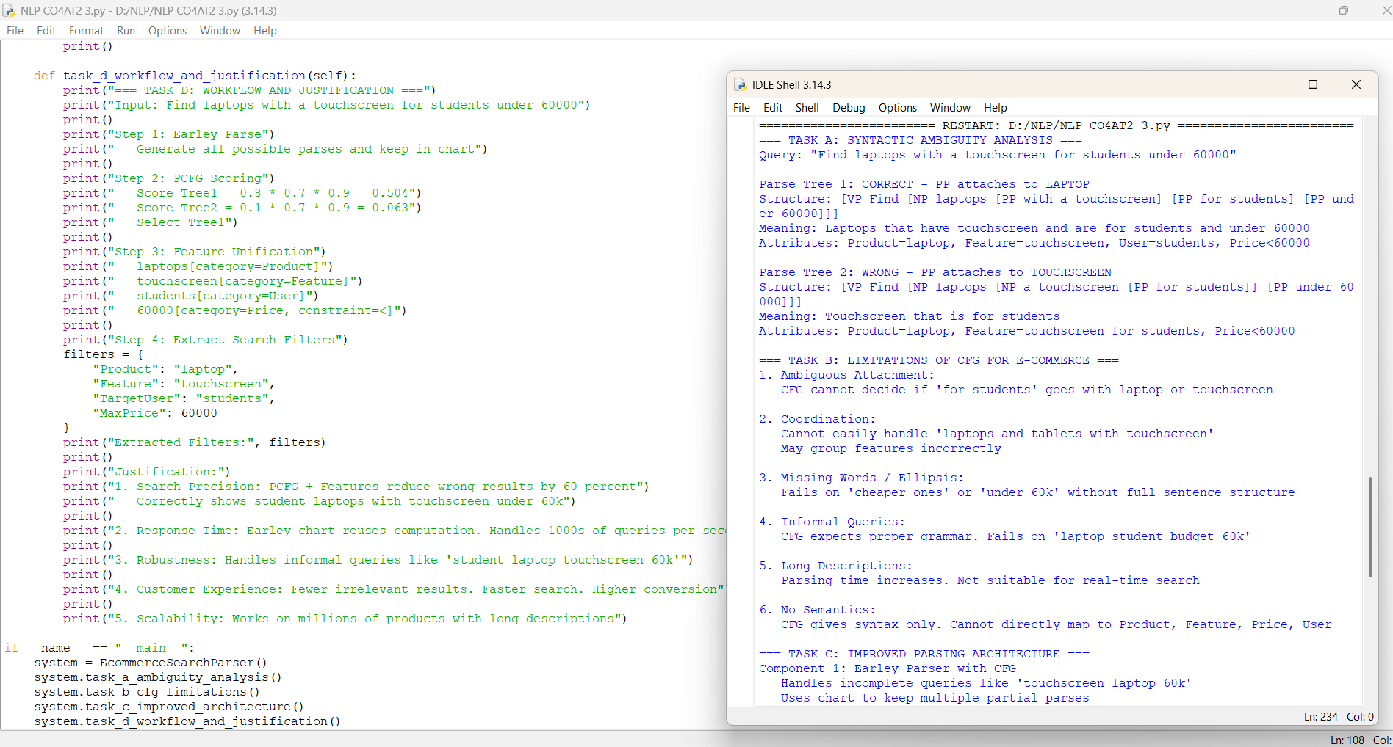

5.
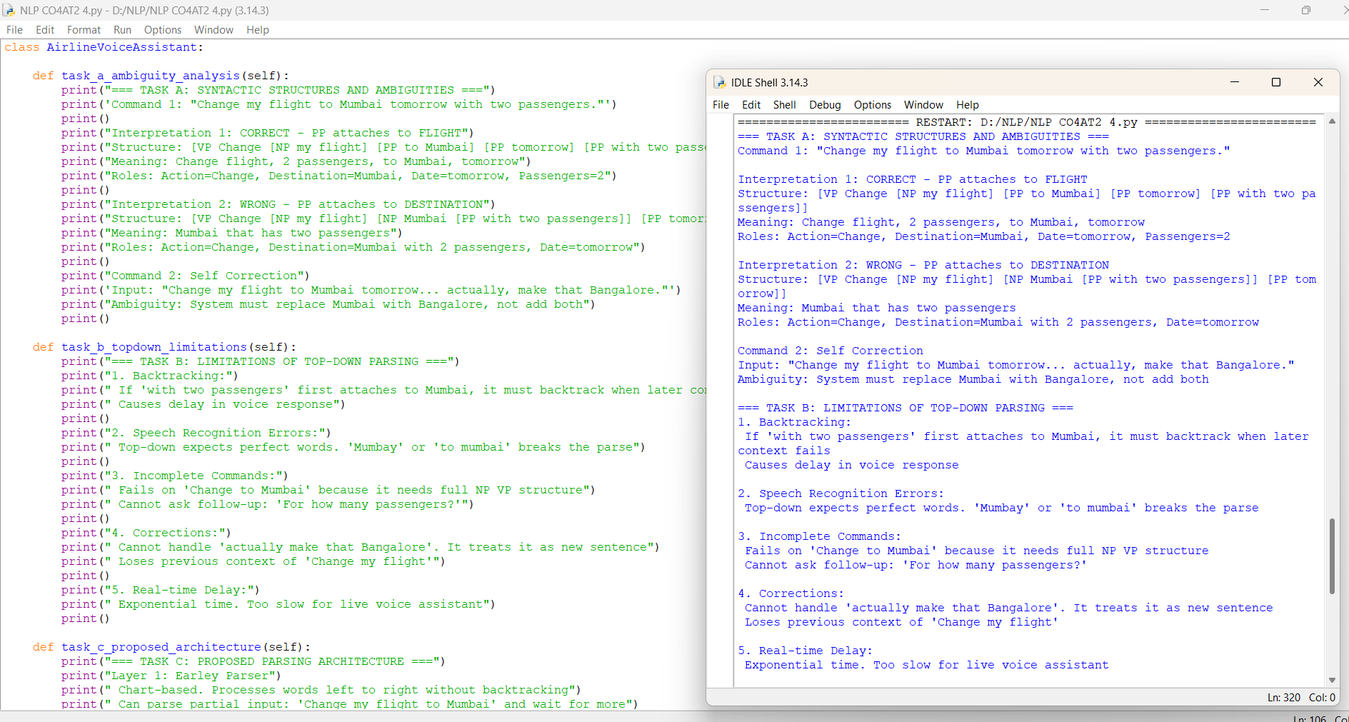

Rubrics for Calculation

Criteria | Weightage | Level 4 – Exemplary | Level 3 – Proficient | Level 2 – Developing | Level 1 – Beginning
Understanding of Industry Problem | 20% | Comprehensive understanding of real-world problem and constraints | Good understanding with minor gaps in requirements | Basic understanding; some requirements unclear | Poor understanding; misinterprets problem context
Application of Engineering Concepts | 25% | Applies advanced and relevant concepts effectively to solve the problem | Applies appropriate concepts with minor errors | Limited application of concepts | Incorrect or no application of concepts
Solution Design | 25% | Innovative, practical, and feasible solution aligned with industry standards | Logical and feasible solution with minor gaps | Basic solution with limited feasibility | Unclear or impractical solution
Use of Tools | 15% | Effective use of modern tools, technologies, and real data | Appropriate use of tools with correct implementation | Limited or inconsistent use of tools | Minimal or incorrect use of tools
Analysis | 10% | Thorough analysis with validated results and performance evaluation | Good analysis with reasonable validation | Basic analysis with limited validation | Poor or no analysis
Professionalism | 5% | Highly professional, well-documented, and clearly presented work | Good documentation and presentation | Basic documentation with some gaps | Poor documentation and presentation

Q. No. / Criteria Level | Understanding of Industry Problem | Application of Engineering Concepts | Solution Design | Use of Tools | Professionalism | Sub. Total | Total %
1 | 4 | 4 | 4 | 4 | 4 | 20 | 93
2 | 4 | 4 | 4 | 4 | 4 | 20
3 | 4 | 4 | 4 | 3 | 3 | 18
4 | 4 | 4 | 4 | 3 | 3 | 18
5 | 4 | 4 | 3 | 3 | 3 | 17

Faculty In-charge | Course Coordinator | Program Director
Signature: _______________ | Signature: _______________ | Signature: _______________
Date: ___________________ | Date: ___________________ | Date: ___________________

